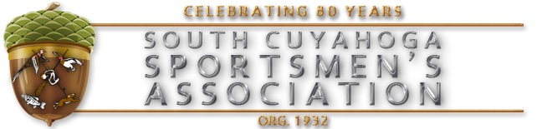

www.idpa.com
2023 IDPA and Steel Matches
South Cuyahoga Sportsmens Association
Chatham Grounds
5370 Erhart Rd., Medina, Ohio 44256
Note: Effective June 1, 2016, Serpa Holsters can no longer be used at SCSA Matches
Registration on Practiscore.com

IDPA MATCH | STEEL MATCH
9:00 Check In | 12:00 Check In
May 21 | May 6
June 25 | June 17
July 30 | July 8
August 27 | August 5
September 17 | September 23
October 15 | October 7
Members $15, Non-Members $20 | Members $10, Non-members $15
Outdoor Bays | $5 for Juniors/or Second Gun
Squadding on Practiscore.com | Squadding on Practiscore.com
Shooting at 10:00 | Shooting at 1:00  (or at the completion of High Power)

Watch our calendar for any updates
Register on Practiscore.com
For more information: www.scsasportsmen.com
Or email Bill Masler at masler3@roadrunner.com
Or Lee Hover at buttonbuckone@aol.com

